2026 GPMGA SGF PLANT SALE OFFERINGS

The Goochland-Powhatan Master Gardener Association (GPMGA) Plant Sale, located at the Goochland Sports Complex, will offer a variety of vegetables, herbs, and annual flower plants grown by the Goochland-Powhatan Master Gardeners from seeds and cuttings, plus plants shared by our members from their own gardens.

Native Plants - In addition to the annual plants listed here, a larger selection of native plants perennials will be available this year. A listing of the natives plants for sale will be posted separately.

Below is a sampling of the beautiful plants grown from seeds or cuttings that will be offered at the sale. The list includes plant descriptions, thumbnail images, and care information. As always, shop early for the best choice!

FLOWERING ANNUALS

(Plants in this group either complete their lifecycle in one growing season or are tender perennials grown as annuals in our area.)

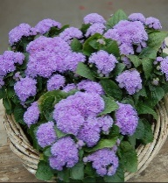
AGERATUM, ALOHA BLUE (Ageratum houstonianum) Annual; 7-12” T x 12” W; A compact, dwarf annual flower, fluffy lavender-blue flowers, blooms from spring to the first frost. Plants are great for borders, edging, containers and mass planting.

Care: Space 15-18” apart in full sun/part shade in average, well-drained soil with regular watering. Remove spent blooms to encourage reblooming.

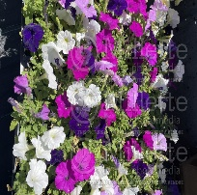
PETUNIA TRITUNIA, ‘MADNESS WATERFALL MIX’ (Petunia x hybrida) Annual; 10-15” T x 10-12” W; Mix of blue, purples, lilac, magenta, royal and white single floribunda petunia offering massive 3-inch blooms. Attract pollinators; Drought tolerant; Blooms Spring to Fall. Ideal for containers hanging baskets and garden beds.
Care: Space 8-10” apart in full sun to partial shade in average, well-drained soil with regular watering. Remove spent blooms to encourage reblooming.

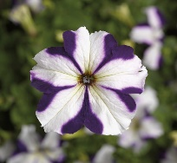
PETUNIA TRITUNIA, ‘BLUE STAR’ (Petunia hybrida ‘Tritunia Blue Star’) Annual; 10-12” T x 12-14” W; A popular, high-performance grandiflora annual featuring 3-4” ruffled, deep blue flowers with a distinct white star pattern. Ideal for borders, hanging baskets and containers. Attracts pollinators; Drought tolerant; Blooms from mid-spring through summer.
Care: Space 10-12” apart in full sun to part shade in average, well-drained soil with regular watering. Remove spent blooms to encourage reblooming.
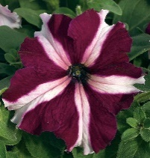
PETUNIA TRITUNIA, ‘CRIMSON STAR’ (Petunia hybrida ‘Tritunia Crimson’) Annual; 10-12” T x 10-12” W; A popular Petunia grandiflora annual, known for its vibrant 3-4” red/burgundy flowers with a distinct white star pattern. Ideal for containers, hanging baskets and garden beds. Attract pollinators; Drought tolerant; Blooms from mid-spring to fall.
Care: Space 14-18” apart in full sun to partial shade in average, well-drained soil with regular watering. Remove spent blooms to encourage reblooming.

FLOWERING ANNUALS (Continued)

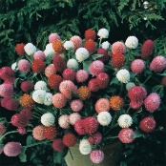
Gomphrena, Tall Mixed (Gomphrena globosa) Annual; 24” T; Mix of lavender-pink, salmon-pastel, purple-rose and white, as well as rosy-oranges and reds in both pastel and deep shades. Makes an ideal border and landscape plant. Strong basal branching plants: Great for mass plantings and cut or dried flowers; Blooms summer to frost; Heat and drought tolerant.
Care: Space 10” apart in full sun in average, well-drained soil with regular watering.

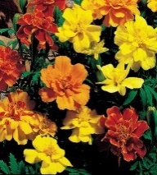
FRENCH MARIGOLD (Tagetes patula ‘Safria Mix’) Annual; 10-12” T x 12-14” W; Award-winning, compact French marigolds, 2-5” double blooms in yellow, orange, gold, red, and bicolor flowers like Bolero. Ideal for containers and borders. Blooms from spring to fall.
Care: Space 8-10” apart in full sun in average, well-drained soil with regular watering. Remove spent blooms to encourage reblooming. Avoid watering in late afternoon or evening.

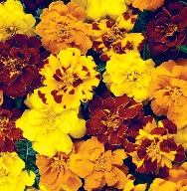
FRENCH MARIGOLD (Tagetes patula ‘Durango Outback Mix’) Annual; 10-12” T x 9” W; Delivers more blooms, stronger stems and better uniformity. Extra-large, 2 to 2-1/2-inch blooms appear early. Solid and bicolor blooms are yellow, gold, and mahogany-red.
Care: Space 6” apart in full sun in average, well-drained soil with regular watering. Remove spent blooms to encourage reblooming. Avoid watering in late afternoon or evening.

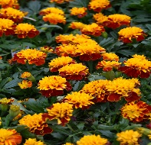
FRENCH MARIGOLD (Tagetes patula ‘Hot Pak Spry’) Annual; 6-7” T x 6-8” W; A dwarf, bushy annual boasting large, double-crested bright orange flowers. The flowers and foliage have a spicy fragance and have been used to deter insects in the garden. Ideal for beds, containers or as edging plants.
Care: Space 6-7” apart in full sun in average, well-drained soil with regular watering. Remove spent blooms to encourage reblooming. Avoid watering in late afternoon or evening.

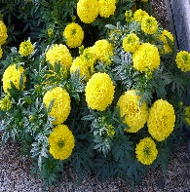
AFRICAN MARIGOLD (Tagetes erecta ‘Taishan Yellow’) Annual; 10-12” T x 8-10” W; A superior dwarf African marigold renowned for its bright, lemon-yellow, ball-shaped blooms and sturdy, thick stems. Ideal for landscapes and containers. Blooms from spring to fall.
Care: Space 6-8” apart in full sun in average, well-drained soil with regular watering. Remove spent blooms to encourage reblooming. Avoid watering in late afternoon or evening.

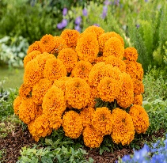
AFRICAN MARIGOLD (Tagetes erecta ‘Taishan Orange’) Annual; 10-12” T x 9” W; A compact, dwarf annual known for large bright orange, ball-shaped blooms and excptional heat tolerance. Ideal for summer long performance in pots, borders, and mass planting. Blooms appear early.
Care: Space 8-10” apart in full sun in average, well-drained soil with regular watering. Remove spent blooms to encourage reblooming. Avoid watering in late afternoon or evening.

FLOWERING ANNUALS (Continued)

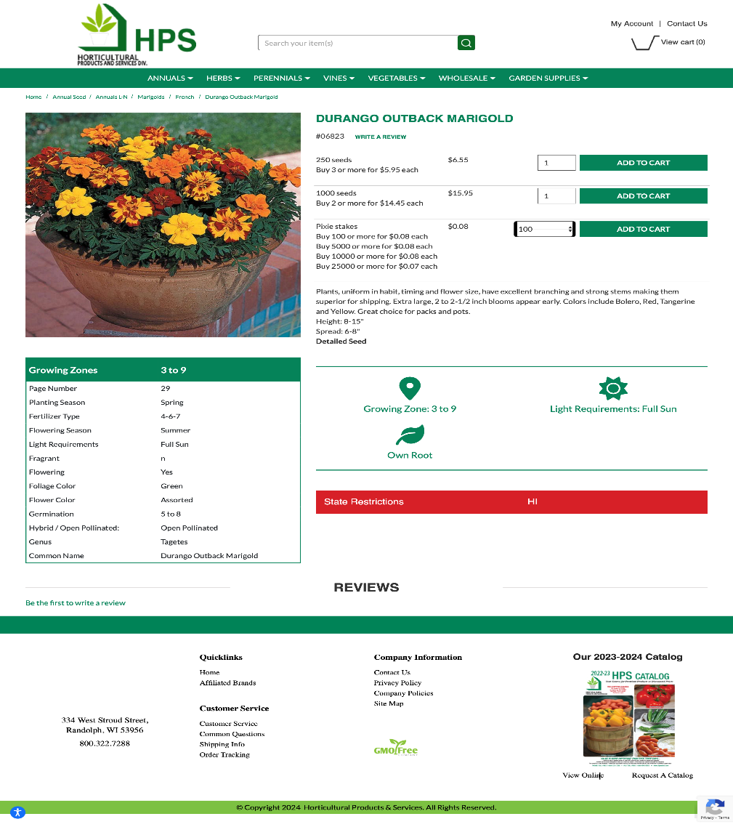
SCARLET SAGE (Salvia coccinea ‘Hummingbird Coral Nymph). Annual; 14-24” T x 12-18” W; Shimmering white and salmon blooms. A stunning pastel bicolor version of 'Lady in Red’ Salvia.
Care: Space 8-12” apart in full sun in average, well-drained soil with regular watering.

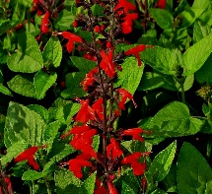
SCARLET SAGE (Salvia coccinea ‘Forest Fire’) Annual; 14-36” T x 12-18” W; A compact striking, fast-growing, and upright perennial known for its brillant, fire-red tubular flowers contrasted against dark, nearly black calyxes and stems. Ideal for borders, beds or containers.
Care: Space 12-18” apart in full sun in average, well-drained soil with regular watering.

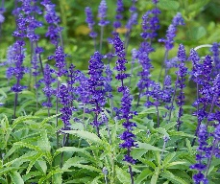
VICTORIA BLUE SAGE (Salvia farinacea ‘Victoria Blue’) Annual; 18-24” T x 16-18” W; A low maintenance compact, and well branched annual salvia known for its long-lasting, deep 8-10“blue flowers. Ideal for borders, beds or containers.
Care: Space 12-15” apart in full sun in average, well-drained soil with regular watering.

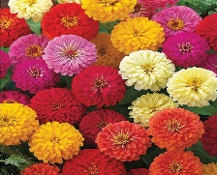
Zinnia (Zinnia elegans ‘Zinnita Mix’) Annual; 6-8” T x 10” W; A dwarf, compact heat-tolerant, and disease-resistant Zinnia elegans variety. Features fully double,4-5” flowers, in bright mixed colors like scarlet, orange, yellow and rose-pink blooms. Ideal for containers, window boxes and borders. Low water needs, and superior all-season performance without constant care.
Care: Space 9-24” apart in full sun in rich, well-drained soil with regular watering.
.
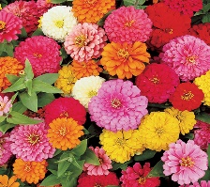
Zinnia (Zinnia elegans ‘Magellan Mix’) Annual; 12-18” T x 10-12” W; A dwarf hybrid Zinnia elegans series, features large, fully double 4-5” blooms in vibrant colors like scarlet, coral, salmon, orange, and ivory. Ideal for bedding, containers and cutting. Outstanding disease tolerance, low water needs, and superior all-season performance without constant care.
Care: Space 10-12” apart in full sun in rich, well-drained soil with regular watering.

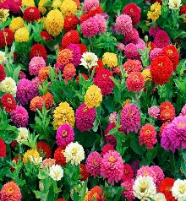
Zinnia (Zinnia elegans ‘Dreamland Mix’) Annual; 10-16” T x 10-12” W; A compact, dwarf plants that are highly prized for their large, 4” dahlia-like blooms. An outstanding mix of vibrant, uniform colors, including ivory, yellow, coral, pink, rose, scarlet, red and apricot. Ideal for containers, borders, and cutting gardens. Early to flower at 6-8”. Perfect for large plantings in beds or for cut flowers.
Care: Space 6-8” apart in full sun in rich, well-drained soil with regular watering.


Zinnia (Zinnia elegans ‘Zahara Single Bonfire’ Mix) Annual; 12-18” T x 12-18” W; A vibrant, heat-loving annual mix featuring 2.5” flowers in shades of scarlet, red and yellow. Known for exceptional disease resistance. Ideal for borders, containers and mass planting. Blooms from spring through summer.
Care: Space 8-12” apart in full sun in rich, well-drained soil with regular watering.

FLOWERING ANNUALS (Continued)

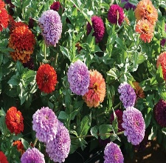
Zinnia (Zinnia elegans ‘Benary’s Giant Mix) Annual; 3-4’ T x 12-15” W; Are premier, easy-to-grow annuals known for large, 4-6” fully double blooms on 3–4’ branching plants. Mix include red, yellow, pink, orange, lime and white. They offer high resistance to mildew, heat and rain. Blooms from mid-summer until the first frost.
Care: Space 9-12” apart in full sun in rich, well-drained soil with regular watering.

FOLIAGE PLANTS
(Plants in this group are grown primarily for their beautiful foliage. They may be annuals, perennials, or tender perennials in our area. Some may produce insignificant flowers.)

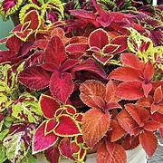
COLEUS (Solenostemon scutellarioides ‘Wizard Mixed’) Annual; 12-14” T x10-12” W; A popular,compact low-maintenance annual foliage plant, ideal for shade, containers, hanging baskets and borders. Known for vibrant, varied leaf colors including rose, jade, golden, sunset and velvet red.
Care: Space 10-14” apart in part shade/partial sun in average, well-drained soil with regular watering. Don’t overfeed for best color.

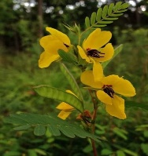
PARTRIDGE PEA (Chamaecrista fasciculata) Annual; 1-3 T’ x 1-3’ W; A fast-growing nitrogen-fixing annual wildflower native to North America., known for its bright yellow, pea-like flowers and feathery leaves that close at night or when touched. Attracts bees, butterflies and other insects. Ideal for pollinator gardens, prairie restoration and erosion control.
Care: Space 6-12” apart in full sun/partial shade in average, well-drained soil with regular watering.

BASIL
(These basil varieties are grown primarily for their flavor or fragrance.) Care: Space 8-12” apart in full sun in average, well-drained soil with regular watering.

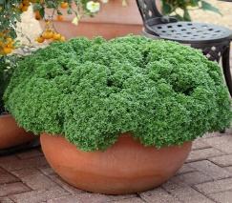
BASIL, Aristotle (Ocimum basilicum ‘Aristotle’) Annual; 10-12” T x 8-10” W; A compact, highly ornamental Greek basil variety featuring dense, small jade-green leaves and a symmetrical, bush-like shape; it. It has a mild, aromatic anise-like flavor. Ideal for containers, windowsills, or edging gardens.

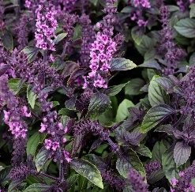
BASIL, AFRICAN BLUE (Ocimum kilimandscharicum x Basilicum ‘Dark Opal’) Annual; 3’ T x 3’ W; a sterile, perennial hybrid of camphor and sweet basil, known for its striking purple flowers, heat tolerance, and strong camphor-like flavor. Ideal for pollinators, blooms profusely all season.

BASIL (Continued)

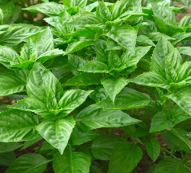
BASIL, RUTGERS OBSESSION DMR (Ocimum. Rutgers Obsession DMR’) Annual; 20-26’ T x 12-15”; A highly disease-resistant Genovese-type leaves, a compact growth habit, and excellent flavor; basil variety developed by Rutgers University to combat basil downy

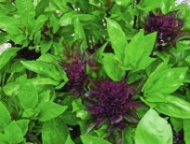
BASIL, CARDINAL (Ocimum basilicum ‘Cardinal’) Annual; 24-30” T; Edible and decorative; A striking. Aromatic herb known for its deep burgundy stems, bright leaves, and dramatic red, pagoda-shaped flower clusters. Ideal for gardens, containers and flower arrangements. Intense, spicy flavor with an anise-licorice flavor; Attracts pollinators.

OTHER HERBS

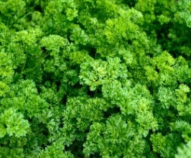
PARSLEY, TRIPLE CURLED (Petroselinum crispum) Annual; 10-12”’ T x 12-15” W; A compact, highly ruffled, dark green, Biennial herb known for its dense foliage, often used as a garnish or ornamental plant. Fast-growing and hardy, thrives in full sun or partial shade.

Care: Space 12-15” apart, in full sun/partial shade, fertile, well-drained soil with regular watering.

PEPPERS
Care: Peppers prefer warm soil. Plant in late spring after the last frost and the soil has warmed. Peppers thrive in full sun in fertile, well-drained soil with regular watering. Mulch to control weeds. Stake or cage to keep plants from breaking under fruit weight. A good slow-release fertilizer added at planting will keep the plants fed throughout the growing season.

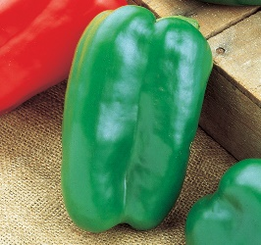
BELL, GREEN > RED (Capsicum annuum ‘Big Bertha Hybrid’) Annual; Open pollinated; 24-36” T; An high-yielding renowned for its large yielding, 2-3 foot tall hybrids pepper known for producing extra-large, elongated, thick-walled, and firm fruit, 7x4 inches long, 4-lobed sweet bell peppers that mature from to green to red. Sweet, mild and crunchy. Excellent for fresh eating, salads, stuffing and stir-fries. Virus tolerant; 70 days to maturity.

PEPPERS (Continued)
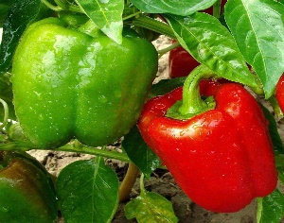
BELL, GREEN > RED (Capsicum annuum ‘California Wonder’) Annual; 2’ T; popular high-yielding heirloom bell pepper renowned for its large, blocky, 4-lobbed shape and thick, crisp, sweet walls. Ideal for stuffing, salads and cooking, it matures from green to vibrant red. Fruit up to 4” x 4 3/4". Foliage provides good cover for fruits. Tobacco mosaic resistant. 75 days to maturity.

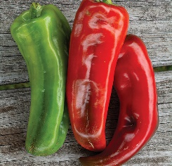
ITALIAN, GREEN > RED (Capsicum annuum ‘Giant Macroni’) Annual; 24-36” T x 3” W; An award-winning, 2001 All-American Selections Winner Italian sweet pepper; known for its large 8-12 inch, sweet, and slightly smoky-favored Italian-type peppers. Ideal for grilling, roasting, or fresh use. These peppers also make great container plants. The plant is resistant to tobacco mosaic virus and potato Y virus. Maturing from green to deep red in 70-90 days.

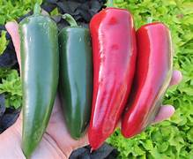
JALAPENO HYBRID (Capsicum annuum ‘Craig’s Grande Jalapeno’) Hot; Are bred for improved disease resistance, high yields, and consistent, large fruit size. Short, stocky plants are loaded with hefty fruits from mid-summer up to frost. Great garden staple for Jalapeno lovers; large 3- to 4-inch-long fruits weigh 3 ounces and have thick flesh making them great for stuffing, roasting, drying, pickling or fresh use. Matures from green to red when they are at their hottest. Scoville Rating: 2500-3000. 70 days to maturity.

TOMATOES
Care: Plant tomatoes after the soil warms sometime after the last frost date in your area. Tomatoes thrive in full sun in average, well-drained soil with regular watering. Mulch to control weeds. Stake or cage at planting time to bear fruit weight and keep plants off the ground. A good slow-release fertilizer added at planting will keep the plants fed throughout the growing season. Space ~30” apart.

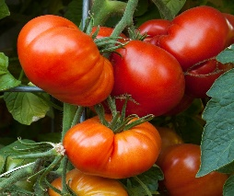
BEEFSTEAK (Solanum lycopersicum ‘Beefmaster Hybrid’) Indeterminate; 4-6’ T x 24” W; Popular, high-yielding indeterminate hybrids s producing massive, meaty red beefsteak fruits, often weighing over 1 lb.– 2 lbs. Known for a classic, sweet and rich flavor. Ideal for slicing. Disease resistant; 80 days to maturity.

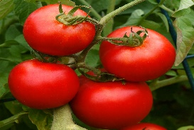
BEEFSTEAK (Solanum lycopersicum ‘Big Boy Hybrid’) Indeterminate; Hybrid; 8’ T x 3; W; A popular, high-yielding, indeterminate hybrid tomato known for its large (up to 1 lb) smooth, deep red, meaty and juicy. Flavorful red fruits, classic taste. Disease resistant 70 - 75 days to maturity.

TOMATOES (Continued)

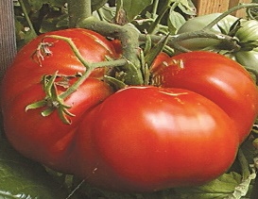
BEEFSTEAK (Solanum lycopersicum ‘Big Zac Hybrid’) Indeterminate; Hybrid; 4-7’ T x 2-3’; An indeterminate, award=winning beefsteak tomato bred for extreme size (often weighing 4lbs). Offers a meaty, classic, slightly acidic and tangy flavor. Ideal for slicing, sandwiches and large-scale gardening. Disease resistant; 80 days to maturity.

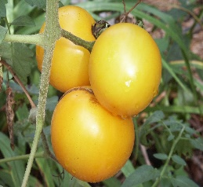
BEEFSTEAK (Solanum lycopersicum ’Lemon Boy Plus’) Indeterminate; 6-7’ T x 24-36” W; A delicious yellow tomato. An improved F1 hybrid indeterminate tomato, offering large (6-7 oz) vibrant yellow fruits. Featuring a mild tangy-sweet favor, long shelf life and high yields. disease resistant; 75 days to maturity.

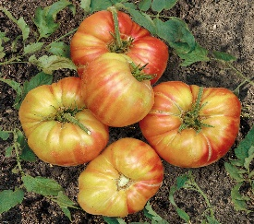
BEEFSTEAK (Solanum lycopersicum ‘Mr. Stripey’) Indeterminate; 4-6’ T x 2-3’ W; Heirloom; A popular heirloom tomato plant known for its large (1-2 lbs.), bi=colored fruits with red and yellow stripes, mild, sweet, low-acid flavor and meaty texture. Virginia heirloom; Beautiful, 1-2 lb. bi-colored, golden yellow fruit with red stripes; Rich, sweet, full tomato flavor; Disease resistant; 80-85 days to maturity.

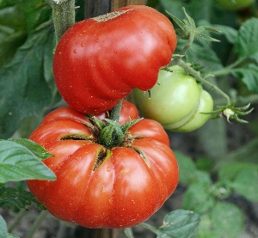
LARGE (Solanum lycopersicum ‘Mortgage Lifter’) Indeterminate; Heirloom; 4-8’ T x 3-4’ W; Very large (1-2 lbs.) smooth, pink-skinned fruit, beefsteak-shaped. Very meaty fruit with few seeds, very mild, low-acid and sweet favor. Ideal for slicing and sauces. Diease resistant; 80-85 days to maturity.

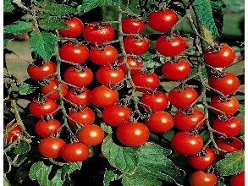
Cherry (Solanum lycopersicum ‘Super sweet 100’) Indeterminate; Hybrid; 4-8’ T X 2-4’ W; A popular cherry tomato variety known for its prolific yields of small (1-inch), very sweet, bright red fruits that grow in long clusters. Ideal for container gardening and hanging baskets. Disease resistant; 65-70 days to maturity.

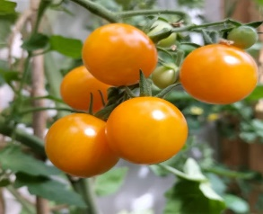
Cherry (Solanum lycopersicum ‘Sungold Select) Indeterminate; 4-6’ T x 2-3’ W; Open pollinated; Bite-size, a cherry tomato offering a stabilized alternative to the popular hybrid Sungold F1. It produces heavy yields of orange, bite-sized (3/4-1 oz) sweet, tangy fruits. Diease resistance; 70 days to maturity.

TOMATOES (Continued)

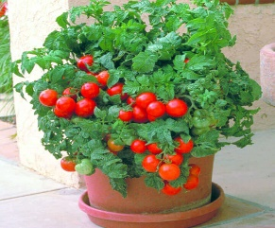
Cherry (Solanum lycopersicum ‘Patio’) Determinate; Hybrid; 2’ T x 18” W; Patio tomatoes are compact, determinate hybrid plants ideal for container gardening and small spaces, producing 3-5 oz fruit, from summer fall. High yields of super-sweet cherry tomatoes; Diease resistant; 70 days to maturity.


PASTE (Solanum lycopersicum ‘La Roma 3.5’) Determinate; Hybrid; 3-4’ T x 2-4’ W; Produces bright red pear-shaped, meaty 5-8 oz. fruits that are full of flavor. Ideal for canning, paste, and sauces; Disease resistant; 65-80 days to maturity.

GOOD TO KNOW TOMATO TERMINOLOGY

GROWING AND FRUIT PRODUCING HABIT
 | Production Period | Plant Size
Indeterminate | Plants grow and produce fruit all season until killed by frost | Large plants generally 6 feet or more tall  Needs substantial staking/caging
Determinate | Plants stop growing and setting fruit when fruit sets on the terminal or top bud – generally sets fruit all at once | Compact plants generally less than 4 feet tall  Needs moderate staking/caging
POLLINATION TYPE
 | Method of Pollination | Advantages
Open-pollinated | Pollinated by insect, bird, wind, humans, or other natural mechanisms | - More genetically diverse  - Plants slowly adapt to local growing conditions and  climate  - Saved seeds come true to the parent plant
Hybrid | Pollen of two different species or varieties is purposely crossed by human intervention to produce a plant with characteristics of both parents | - The first generation of a hybridized plant tends to grow better and produce higher yields than the parent varieties  - Seeds saved from hybridized plants will not have the same characteristics as the hybridized plant – some may be sterile
Heirlooms are generally open-pollinated varieties that are over 50 years old whose seeds
have been carefully saved and handed down from gardener to gardener

OTHER VEGETABLES

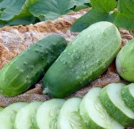
Cucumber, pickling (Cucumis sativus ‘Pickling’) 5- 8’ Specially developed for home gardeners, vigorous plants with good disease resistance, including downy mildew resistance. Medium green fruit with small white spines is solid and crisp, up to to 6” long; Good for pickling (harvest at 1 1/2” or larger). Makes robust bite sized pickles, slices, or large spears; 50-65 days to maturity.
Care: Space 12” apart (trellis for straightest cucumbers) in full sun in loamy, well-drained soil with regular watering.
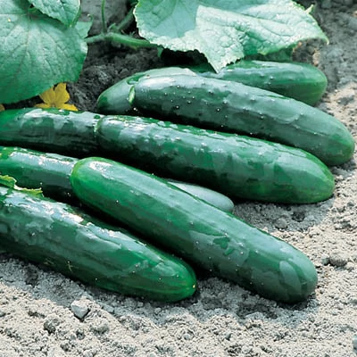
Cucumber, slicing (Cucumis sativus ‘Marketmore 76’) Open-pollinated; Slicing cucumber 8-10” long with dark green skin; Non-bitter; Monoecious: male and female on the same plant; Good disease resistance; 70 days to maturity.
Care: Space 18-36” apart (trellis for straightest cucumbers) in full sun in loamy, well-drained soil with regular watering.

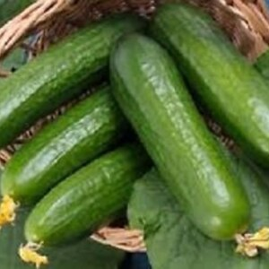
Cucumber, MINI-ME F1 (Cucumis sativus ‘Mini-ME F1’) Self-pollinating; A highly productive, early maturing Beit Alpha-type cucumber. Ideal for snacking, It produces small tender cucumber four-to six inches in length with a smooth exterior, thin skin, and very few seeds.; Diease resistant; 45 days to maturity.
Care: Space 18” apart, in full sun, in loamy, well-drained soil with regular watering.

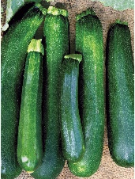
squash, black beauty (Cucurbita pepo ‘Black Beauty Zucchini Squash)’ This continual bush-type plant produces 6” to 8” cylindrical fruits that are straight and slender with slight ridges. The fruit is very dark, turning C

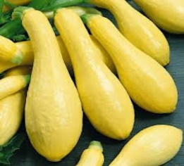
SQUASH, YELLOW SUMMER (Cucurbita pepo ’Straight Neck’) Beautifully bumpy with bright, yellow skins, will roduce abundant fruits all season long. Fruits are 5”- 6 long, fine meaty texture and succulent flavor, 60 days to maturity.

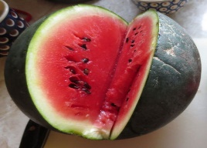
WATERMELON (Cucurbitaceae ‘Sugar Baby’’) Open-pollinated; A smaller, icebox-type watermelon with heirloom quality, sweet flavor. Dark green exterior and bright red interior. Very sweet. 75 days to maturity.
Care: Space 24” apart in full sun in fertile, well-drained soil with regular watering.

.
OTHER VEGETABLES (Continued)

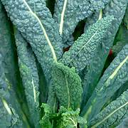
KALE (Brassica oleracea var. palmifolia ‘Lacinato’) Open-pollinated, also known as Tuscan Kale, Italian heirloom, sweeter, mild, heavily crinkled blue-green leaves strap impart excellent flavor. 65-80 days to maturity.
Care: Space 1-1 ½’ apart in full in fertile soil, well-drained soil with regular watering.
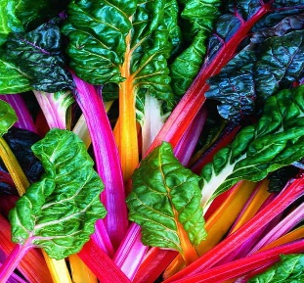
SWISS CHARD (Beta vulgaris ssp. Cicla ‘Bright Lights’) Open-pollinated; A bouquet of multicolored stems and wrinkled green and bronze leaves. 65-70 days to maturity.
Care: Space 1-1 ½’ apart in full in fertile soil, well-drained soil with regular watering.

