Seeds - Sexual Plant Propagation
- variations depending on genetic influences and combinations
February 3, 2026

Spores - Ferns, moss - also, mushrooms and other fungi
Seeds - Seed Components: seed coat, embryo, endosperm
Monocots and dicots
What’s the difference between Heirloom and Hybrid?
Growth and ripening of seeds
Annuals - From seed to maturity in 1 yr.
Biennials - 1st season-edible crop - 2nd season – flower & seed
Perennials - Produce seed a year or two after planting
Pollination habits of plants
Perfect flowers –all in 1 flower
Self-pollination and cross pollination
Imperfect flowers
Separate male & female flowers
Monoecious & Dioecious plants
How pollen travels: wind, birds, ants, humans
Hand pollination - For advanced seed savers
Planning to save seeds
Isolation of target plants
Identify and save the prize
Be aware of hybrids
Harvesting seeds - Right time
Selecting viable seeds
Preparing seeds for storage
Dry thoroughly - Clean and sort
Package and LABEL
Include species name and date of collection
Store in cool, dark, dry location, free of pests
Preparing to plant seeds
Length of viability - Tests for viability
Check for mold, mildew, and other pests
Seed dormancy – block to germination
Breaking dormancy - Imbibition
Scarification
Mechanical - hot water, chipping, sandpaper
Chemical - Acid – be careful
Stratification - After-ripening - Imitates nature
Natural stratification - Native plants
Timing – plant after the last frost date
Viability
Planting depth
Dicots – 1.5 x diameter
Monocots a bit more
Temperature
Warm weather seeds - Won’t germinate if it’s too cold
Good to start indoors
Cold weather seeds - Won’t germinate if it’s too hot
Generally direct sowing
Starting seeds indoors
Early start for delicate plants
Hardening off before transplanting
Starting seeds outdoors – directly in the ground
Sturdy plants – no transplanting
Self-sowing plants – thinning
Germination – 4 environmental factors
Air, Moisture, Heat, Light
WORKSHOP – planting seeds
Purple-headed Sneezeweed - Helenium flexuosum - Tiny seeds
Transplanting seeds
Separate with care - Touch the roots and the leaves
Never touch the stems!!!!
WORKSHOP – practice with out-of-season seedlings
Grape tomatoes
Hardening off - Toughening up for transition to the garden
Cut back on water
At 50º put outside in protected area
Gradually move to desired area
Damping off – a fungal disease
Sterile containers and soil or solarizing soil (outside)
Plant fresh healthy seeds
Good air circulation, heat and light
Avoid overcrowding
Don’t overwater

---------------------------------------------------------------------------------------------------------
BIBLIOGRAPHY AND RESOURCES
Dirr, Michael A. and Charles W. Heuser, Jr. The Reference Manual of Woody Plant Propagation, 2nd ed.,
From Seed to Tissue Culture. Portland OR: Timber Press, Inc., 2006.
Druse, Ken. Making More Plants: The Science, Art and Joy of Propagation. New York: Adams, Henry N.
Inc., 2012.
Gough, Robert E. The Complete Guide to Saving Seeds: 322 Vegetables, Herbs, Fruits, Flowers, Trees and
Shrubs. North Adams, MA: Storey Publishing, 2011.
Toogood, Alan, ed. The American Horticultural Society Plant Propagation. New York: DK Publishing, Inc.,
1999.
Thompson, Peter. Creative Propagation. Portland, OR: Timber Press, 2005.
Turner, Carole B. Seed Sowing and Saving: Step-by-step Techniques for Collecting and Growing More than
100 Vegetables, Flowers and Herbs. North Adams, MA: Story Publishing, 1998.

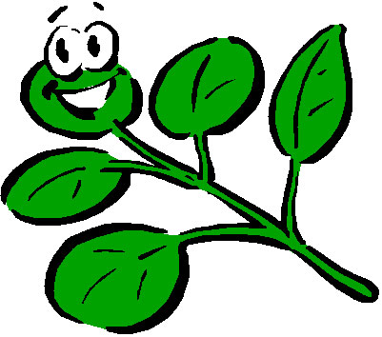 Contact Information: lustpd@longwood.edu

Pat Lust - EMG Volunteer
Goochland Powhatan Master Gardener Association
ww.gpmga.org

